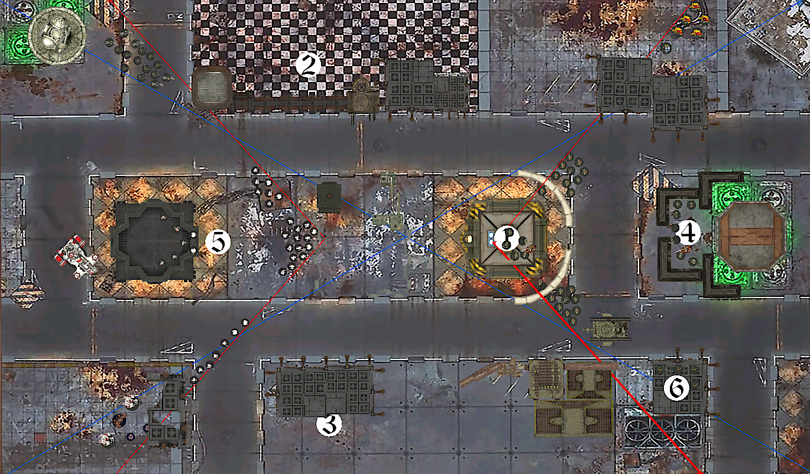

Librarian

Stenguards

Company Cmd

Platoon Cmd

Leman Russ

Squad 2

Squad 1

Squad 1

Squad 2

Krouts

Hammerhead

Line Squad

Commander & Crisis

# TOUR 1